About-Me Web Page

In this project, you will create an “About Me” web page containing some basic info about you.

This assignment is meant to be a bit tedious. There are a lot of little parts to it. In order to really learn HTML you have to spend time with it. That means doing a lot of stupid tedious stuff.

Sorry.

Try and have fun with it.

A significant part of this assignment will be looking up the various HTML elements on the web. As a web developer, you need to get used to Googling stuff. Certain things you’ll need to know off the top of your head, but you’ll find yourself looking things up constantly.

A good place to start is w3schools: <http://w3schools.com>. Look for their HTML tutorial (If you can’t find it on their website, I bet Google can).

# Assignment description

Your web page must have the following, in this order:

1. You must call your file index.html. I’ll take off 5 points if you don’t do this.
2. (5 points) HTML header
   1. Make sure you set it to tell the browser you’re using HTML5
   2. Set the title, which appears on the browser’s title bar. The title should read: About <your-name>
3. (10 points) At the top of the page
   1. Put your name in a header, level 1.
   2. Put a recognizable picture of you.
      1. Please use a paint program to resize and crop your image so that it is no larger than 500 by 500px (It does not have to be square).
      2. If the image looks squashed or stretched I’m going to take off points.
      3. The image should live in the same folder as your HTML page.
4. (10 points) Your personal info
   1. Have a header (level 2) that says: “Personal Info:”
   2. Next, use an unordered list (bullet points) and give me the following pieces of info:
      1. Your major (spell it out. Don’t abbreviate).
      2. Your high school, and the year you graduated.
      3. What year are you in, currently, at UVU.
      4. Your favorite flavor of ice cream (mmmm, ice cream).
   3. Make use bold text for each label like in the example that I provided below.
5. (10 points) Five favorite books
   1. Have a level-2 header titled “My five favorite books”
   2. Choose five books that you like the best, and list them in the order of your preference.
   3. Each title should be italicized. Each author’s name should be in regular text.
   4. Add hyperlinks. For each of the five books you listed, make the author’s name a hyperlink to the author’s website.
6. (10 points) Compose a haiku or a limerick, or other short poem (3 or 4 lines). Please keep your poem PG-rated (no potty humor, no sexually suggestive stuff).
   1. Have a level-2 header with a title of your poem
   2. Have a sentence or two explaining your inspiration for the poem.
   3. Put your poem after the header.
   4. Each line should use line-breaks, not paragraph breaks.
7. (15 points) Brief essay
   1. Make a level-2 header titled something like: “My personal interests”
   2. Give me three paragraphs, with three or more sentences each. In each paragraph talk about something you’re interested in.
8. (30 points) Class schedule: I want you to create a table that shows your weekly class schedule. This is easy to do using table elements, but it does require some attention to detail.
   1. Make a level-2 header titled “class schedule”
   2. Create a table with 6 columns.
   3. Set the border size to 1, so I can see the borders for each cell. Set the cell spacing to 3, and set the cell padding to 3.
   4. The header row should have a blank cell, followed by cells for Monday, Tuesday, Wednesday, Thursday, and Friday. If you have a Saturday class (you poor soul), you can add a sixth column (or not, I don’t care, really).
   5. Going down the left side of the table, I want you to list out the hours of your week-day in 30-minute increments. You can start as early as you feel necessary.
   6. List the classes you have as cells. Use the row-span element to block out as many 30-minute cells as you need for each item. If you have stuff that starts at an odd time, then guess. I won’t care, as long as it doesn’t look all wonky.
   7. Fill up your schedule. Make stuff up if you have to. I want to see at least four classes that run M-W-F or Tu-Th or every weekday. In addition to classes, You can put your employment, your work-out time, your commute time, or anything else you like.
   8. Use the rowspan attribute, so if you have an hour-long class, the cell should take up two rows, without a line between them.
9. (10 points, max) Do any five of the following things. You will need to find this stuff out for yourself:
   1. **(2 points) Can you set a repeating background image?** The text should still be readable. Pick something that doesn’t make my eyes bleed, or I won’t give you credit.
   2. **(2 points) can you change the font** used in the body of the document to something besides Times New Roman (or whatever your browser uses by default)?
   3. **(2 points) can you make your photo right-aligned** on the page, and make the page’s text flow around it?
   4. **(2 points) on all hyperlinks,** can you make it so that the underline only appears when you mouse-over the link?
   5. **(2 points) find a way to indent your poem**, or center it on the page.
   6. **Weekly Schedule** 
      1. **(2 points) text alignment.** On your schedule, can you find a way to have all the text vertically aligned to the top and horizontally aligned to the left (including the headers).
      2. **(2 points) on your weekly schedule, can you fill in in each block** so that each thing is color-coded in its own color (English is yellow, calculus is light red, work is light blue, etc)?
      3. **(2 points) equal column widths.** On your schedule, can you find a way to have the column widths fixed so that they’re all the same size

When doing your weekly schedule, make sure your table doesn’t show any of the following errors or I will deduct points:

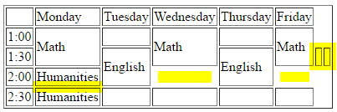

Extra blank cells at the end of a row

Block of time that takes a whole hour, but uses two separate cells

Missing cells

# Sample web-page

Here is a sample of what I’m talking about. The fonts may vary. Don’t worry about how your page looks. All I really care about is can you get it to come out roughly like what I describe in this document (this example would be worth 92 points):



Tom Abbott



Personal Info

* **Major:** Computer Science
* **High School:** Kadena High, Okinawa, Japan. 1987
* **Current year at UVU:** Sophomore
* **Favorite ice cream:** Bear Claw

Five favorite fantasy novels

1. *Lord of the Rings*, J. R. R. Tolkien
2. *Harry Potter*, J. K. Rowling
3. *Chronicles of Narnia*, C. S. Lewis
4. *A Wizard of Earthsea*, Ursula K. LeGuin
5. *Son of the Black Sword*, Larry Corriea

A Haiku I Wrote

Ode to my co-worker, whose desk is too close to mine:

*The slurping man slurps*

*herba mate all day long*

*I crank my headphones*

Personal interests

I like writing. I started about 11 years ago, after I moved to Utah. I’ve won a few minor awards, but right now I don’t have a lot of time. I’ve completed one novel and three short stories. Two of my short stories took Honorable Mention with the L. Ron Hubbard Writers of the Future contest.

I also like historical european martial arts (HEMA). When I have time I study with a group of HEMA enthusiasts in Provo. We study old manuscripts from the 1300s and 1400s and learn fighting techniques with two-handed longswords.

I also teach college as an adjunct professor for both BYU and UVU. This was an unexpected opportunity, which fell into my lap. It takes a lot of time and it is tough, but I get to work with a lot of people and make friends, and share the things that I’ve learned in my career.

Class schedule

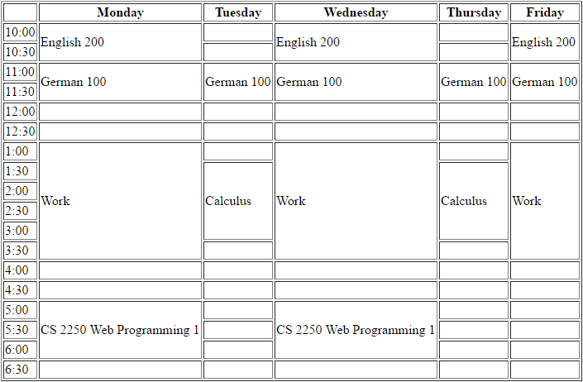

# Submitting your work

Please create a .zip file (please use .zip, not .rar, or … anything else. I don’t want to have to hunt all over the internet to open up some weird format).

Your .zip file should have two files in it:

1. The HTML file for your page. Your file must be called index.html or I’ll take off points.
2. Your picture, which your web page pulls in.

I should be able to open up your .zip file, copy all the files to a temp folder, then open up your web page.